**NAME:** HEMA PRIYA H **REG. NO.:** 211419106103

**ASSIGNMENT-1**

**SMART HOME USING TINKERCAD**

**CIRCUIT:**

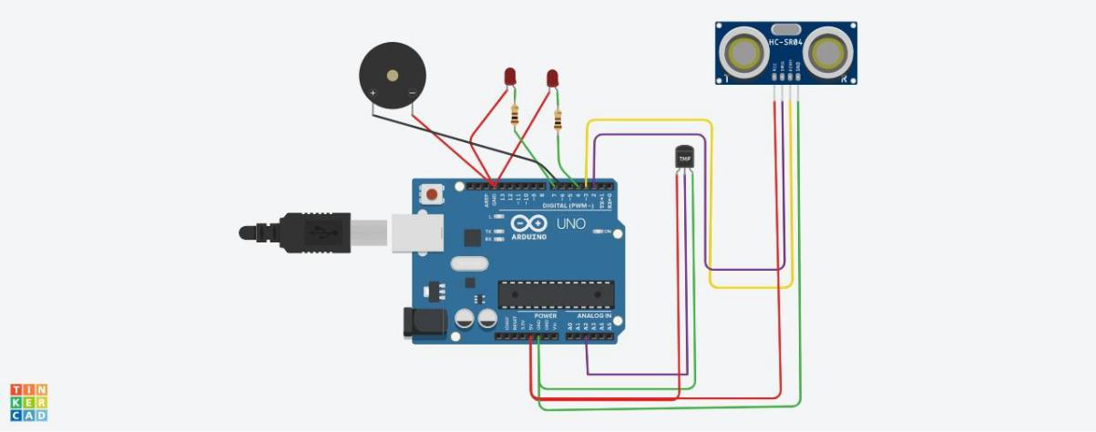

**SIMULATION:**

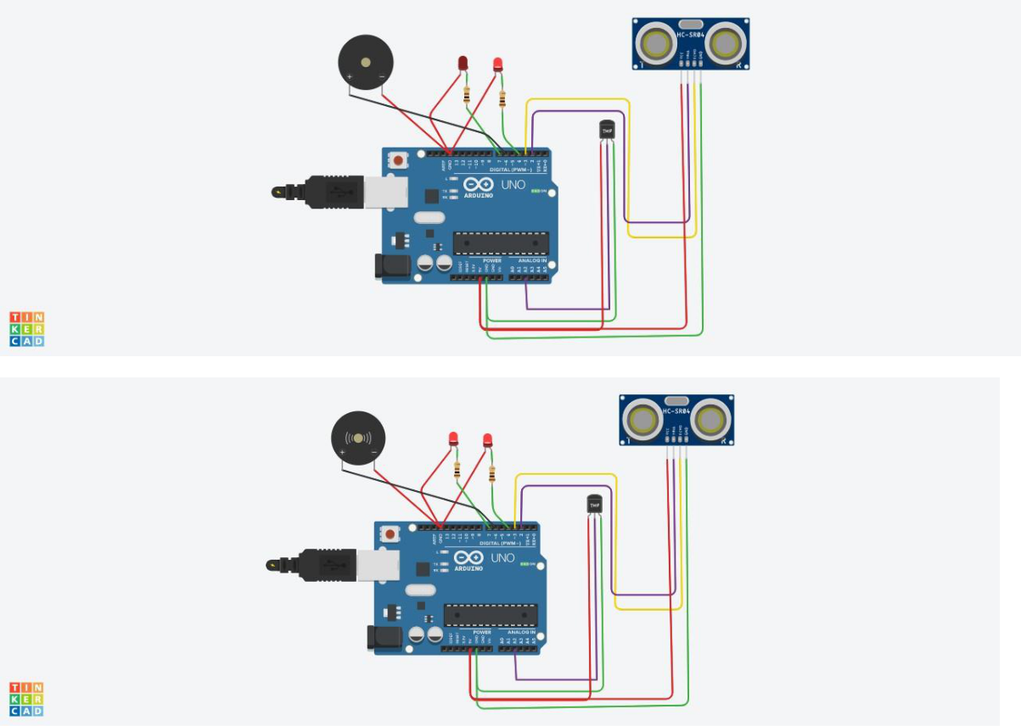

**NAME:** HEMA PRIYA H **REG. NO.:** 211419106103

**CODE:**

* C++ code int trig = 2; int echo = 3; int led=4; int buz=6; int led1=7; void setup()

{

Serial.begin(9600);

pinMode(trig,OUTPUT);

pinMode(echo,INPUT);

pinMode(led,OUTPUT);

pinMode(led1,OUTPUT);

pinMode(buz,OUTPUT);

}

void loop()

{

* temperature sensor double t = analogRead(A2); Serial.print("Analog data: "); Serial.println(t);

double n= t/1024; double v=n*5; Serial.print("Voltage data: "); Serial.println(v);

double c=v-0.5;

double k=v*100;

Serial.print("Temperature value:");

**NAME:** HEMA PRIYA H **REG. NO.:** 211419106103

Serial.println(k);

delay(1000);

//ultasonic sensor

digitalWrite(trig,LOW);

digitalWrite(trig,HIGH);

delayMicroseconds(10);

digitalWrite(trig,LOW);

float dur=pulseIn(echo,HIGH);

float dist=(dur*0.0343)/2;

Serial.print("Distance in cm : ");

Serial.println(dist);

//led

if(dist>=100)

{

digitalWrite(led,HIGH);

}

else

{

digitalWrite(led,LOW);

}

//buzzer

digitalWrite(buz,LOW);

digitalWrite(led1,LOW);

delay(1000);

digitalWrite(buz,HIGH);

digitalWrite(led1,HIGH);

delay(1000);

}